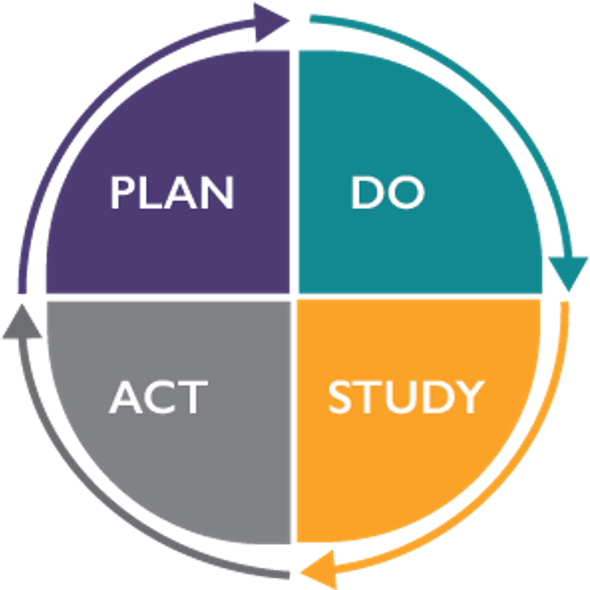
PDSA Worksheet

This PDSA Worksheet is intended to help you think through and document your Plan-Do-Study-Act (PDSA) Cycles as you test change ideas. Doing small, iterative tests of change using a PDSA cycle is one of the central components of all quality improvement work.

PLAN
Overarching Project or Team Name: | Test of Change Start Date: | Test of Change End Date:

Project SMART (Specific, Measurable, Achievable, Relevant, Time Bound) Aim:

Potentially Better Practice (PBP) or other related driver of change:

What is the change idea?

How will you know the change is an improvement?

What questions do you want to answer?

What are your predictions?

Briefly describe the change to your practice or process that is being tested:

Describe the following elements of your test:

What? (the specific task) | How? (Checklist, communication, chart audit, education) | Who? (Name or role | When? (Specific time/date) | Where? (Specific unit or area)

Describe your plan to collect data that will answer your questions:

What data will be collected? | How? (Checklist, communication, chart audit, education) | Who? (Name or role | When? (Specific time/date) | Where? (Specific unit or area)

DO: Test the changes
Gather data and list your observations:

What did you observe that was not part of the plan?

Review your data and describe the results.

STUDY

How do the results compare with your predictions?

What did you learn from this cycle?

Decide whether you are going to adapt, adopt, or abandon your change idea and complete the corresponding section below.

ACT: Adapt, Adopt, or Abandon

ADAPT: Improve the change and continue the testing plan. This is the option you should choose most often as you apply the learnings of small tests of change.

Describe plans/changes for your next test below (may include testing on a different/larger population).

ADOPT: Select changes to implement on a larger scale and develop an implementation plan, and a plan for sustainability. This option is appropriate following repeated tests of change to refine your new process.

- Describe the preliminary plan.

- Identify your measurement plan to assess whether the changes are being sustained.

ABANDON: Discard this change idea and try a different one. Your balancing measure(s) may help to inform this choice.

- Describe your rationale for testing a different change.

- What do you plan to test next?

